**Homework Assignment: Forensics 101**

This little guy might look cuddly and cute...but he assisted my cat in eating my homework!

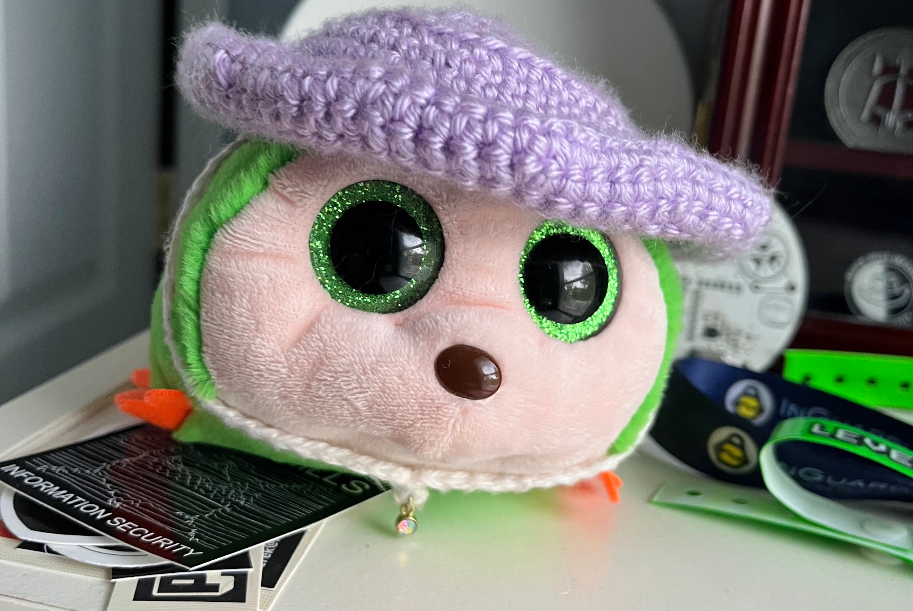Photo Credit: Chloe Regas

**The flag is: csawctf{C@ts_Luv_3@7ing_p@per!}.**